Data download instructions:

Fish data:
- https://datras.ices.dk/Data_products/Download/Download_Data_public.aspx
- Select according to this screenshot
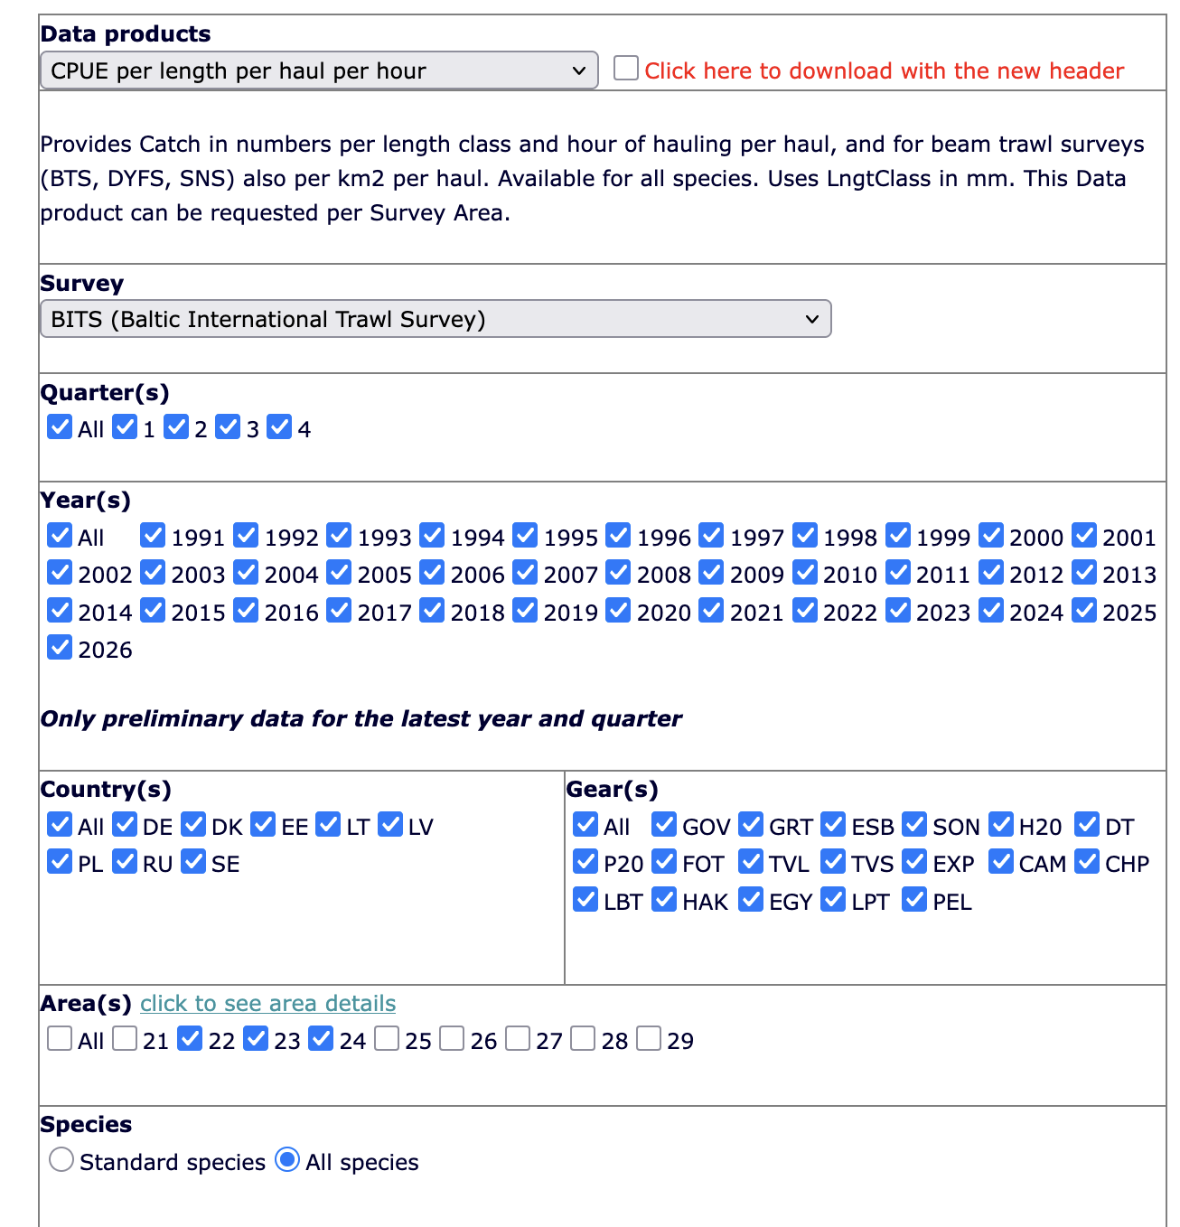
- Select all the species you are interested in

Use the ICES shapefiles to attach the official ICES subdivisions by geographical position to your data sets. Then you can compare your data by area if you want to.

